Practice Questions – Cycle 1

1 Display your current directory.
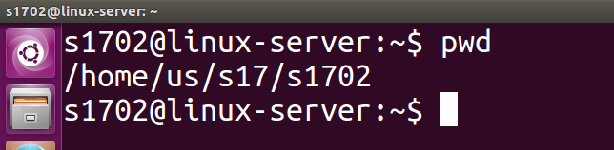

2 Change to the /etc directory.

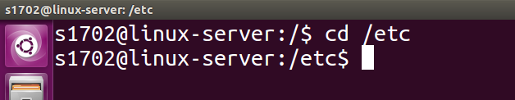
3 change to your home directory using a single command.
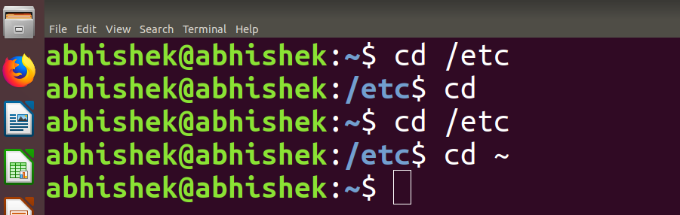

both cd or cd ~ can be used
4 Change to the parent directory of the current directory.

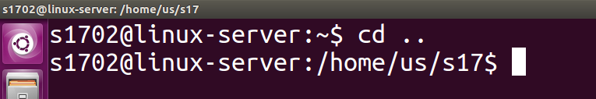
5 Go to the root directory.
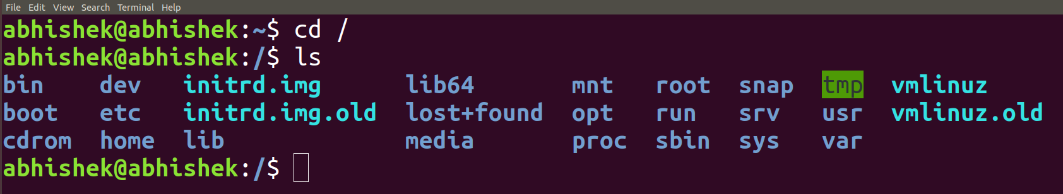
6 Give a long listing of the root directory.
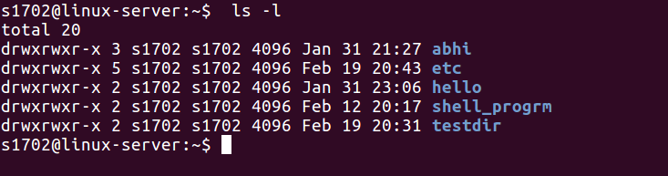
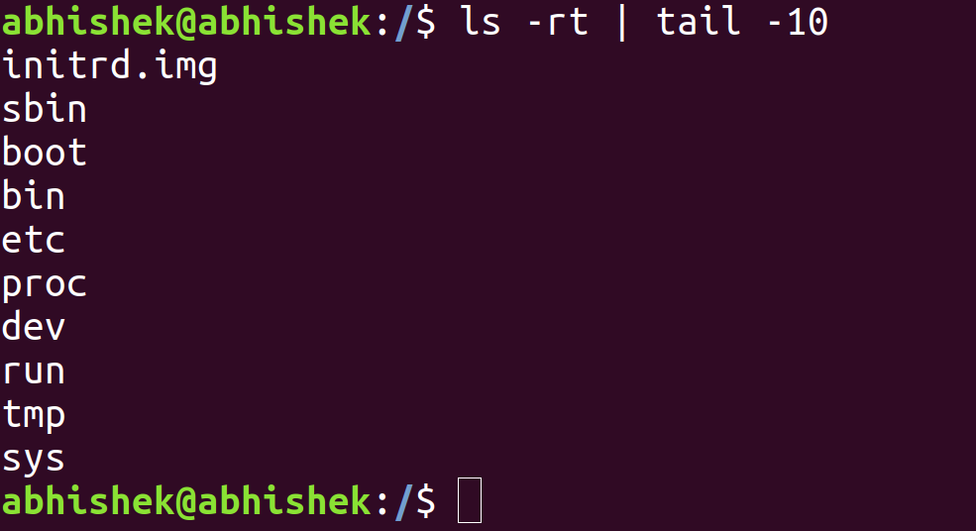
7 Give a listing of the last 10 files in the root directory.

8 Stay where you are, and list the contents of /etc.
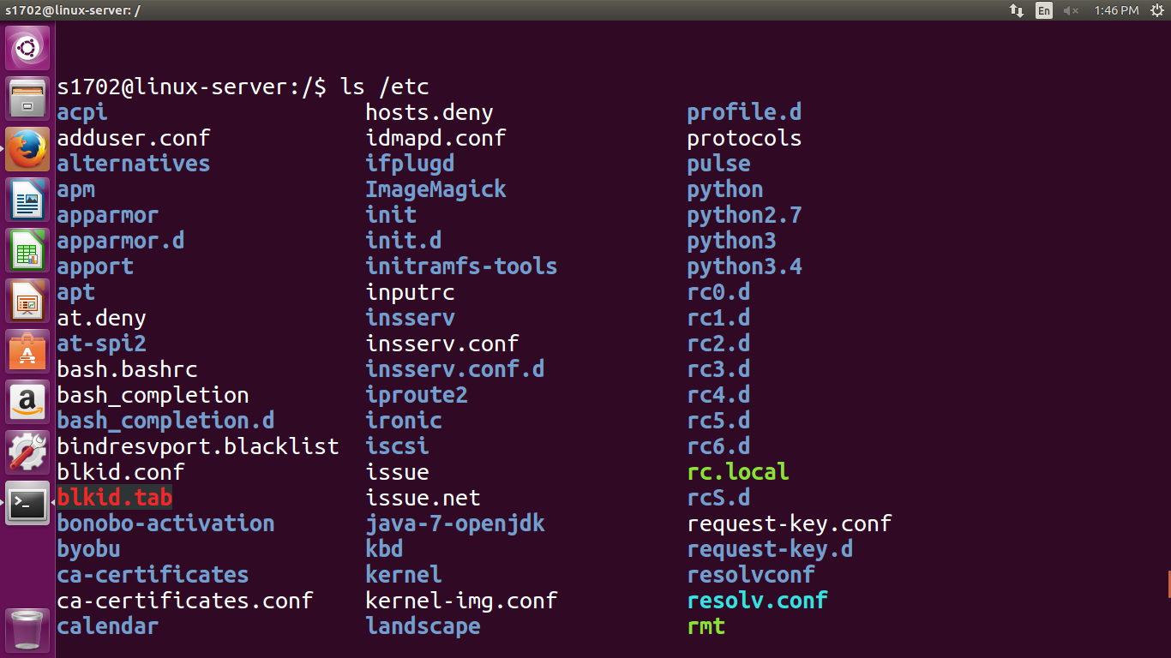

9 Create a directory testdir in your home directory.
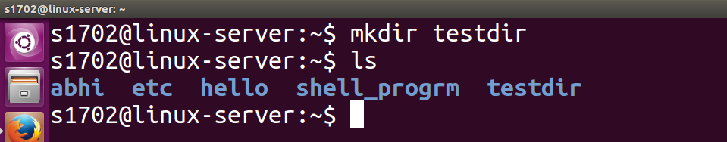
10 Change to the /etc directory, stay there and create a directory newdir in your home
directory(using a single command).
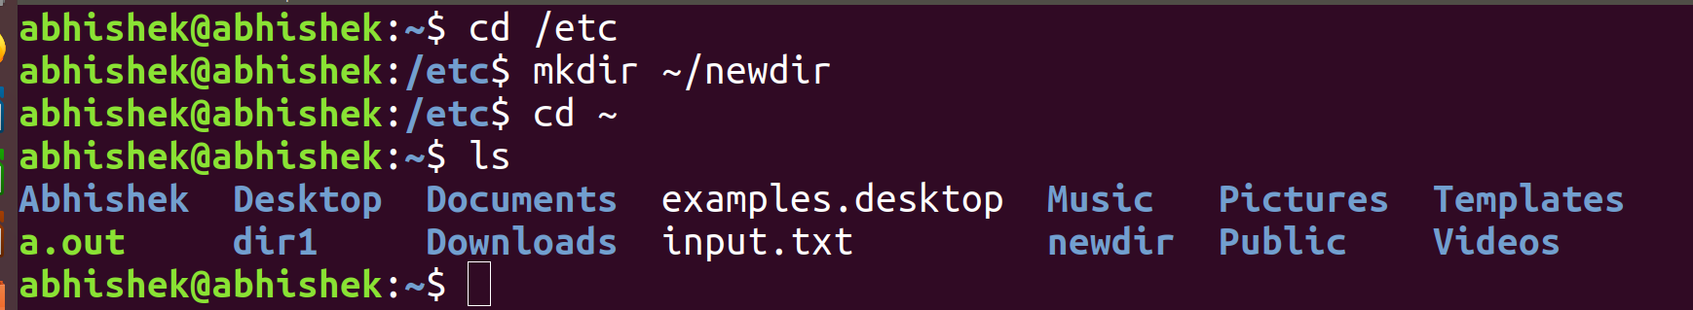
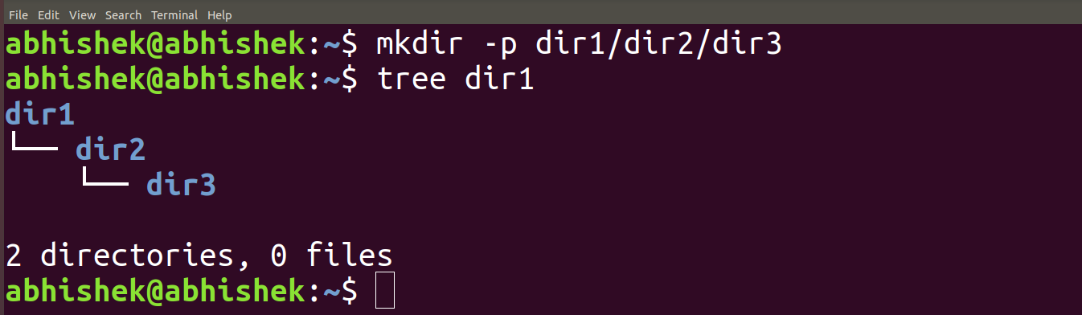
11 Create in one command the directories ~/dir1/dir2/dir3 (dir3 is a subdirectory from dir2, and dir2 is a subdirectory from dir1).

12 Display the calendar for April 2019.
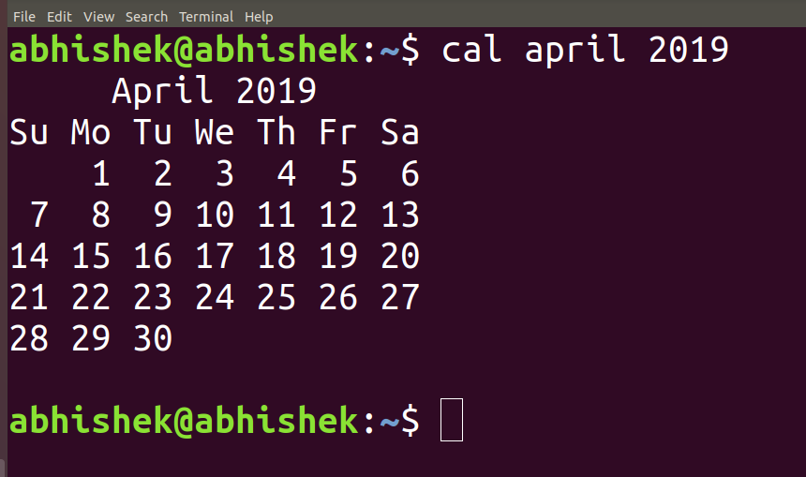
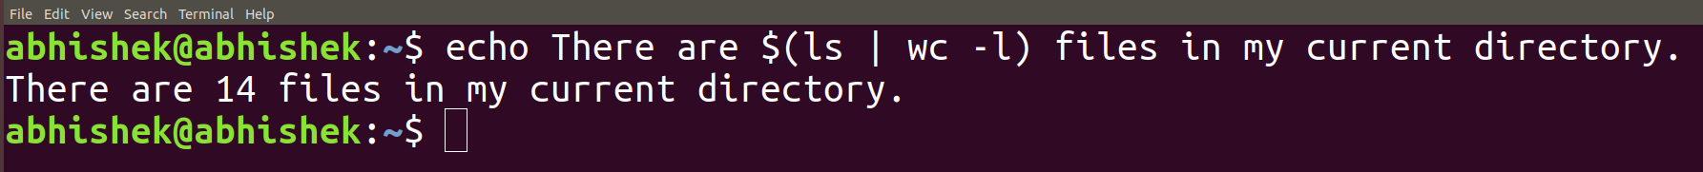
13. Display that ‘There are ................ files in my current directory’ . The ..... should be filled with the count of the files.

14. List all the files (including hidden files) in your home directory.

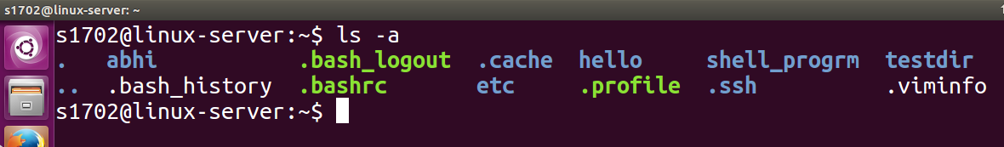

15. Redirect the output of the above command to a new file FileList.txt.

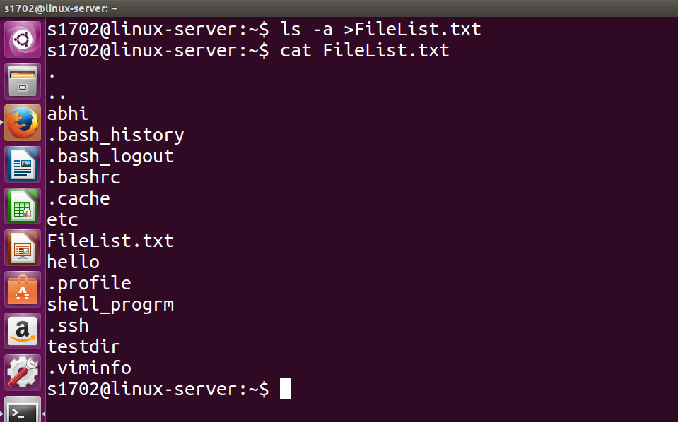
16. Redirect the number of lines of FileList.txt to CountFile.txt.
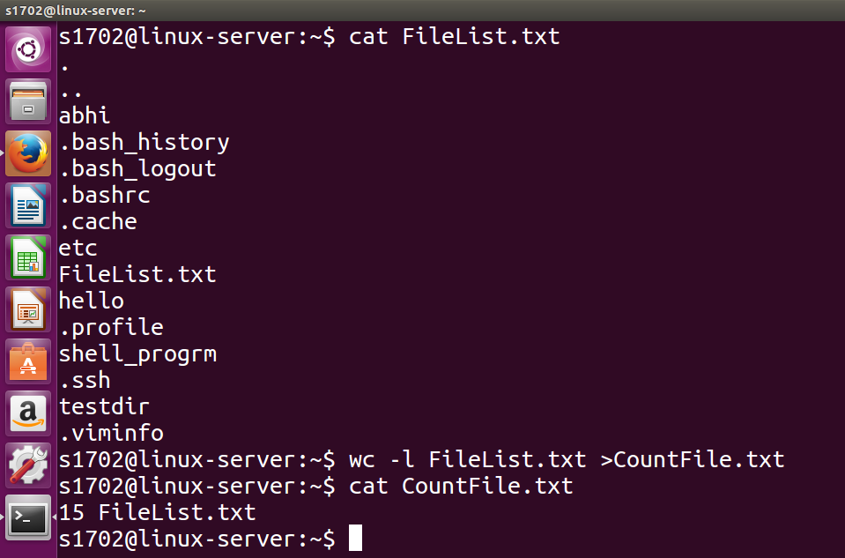

17. List all the files in your home directory starting with ‘s’ .
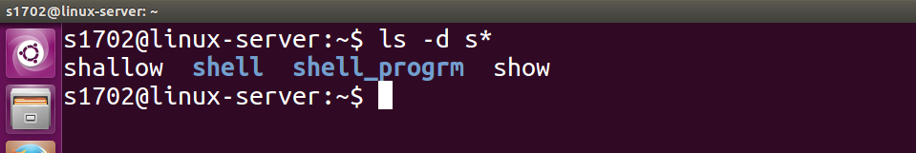
18. List all the file-names starting with “a”, “b” or “s” .
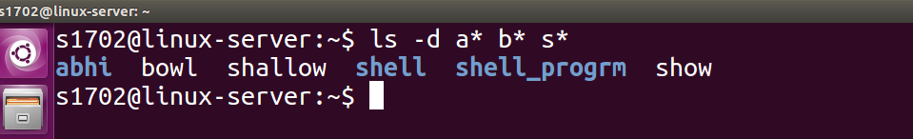

19. Create two files ‘Countries.txt’, containing country names and their corresponding capital cities and ‘Story.txt’ contains some arbitrary lines of text.

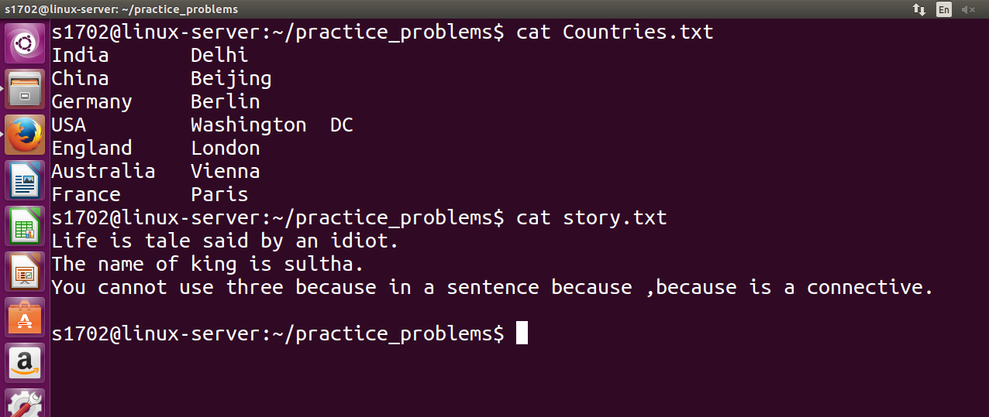
20. Convert all lowercase characters from ‘Story.txt’ to uppercase and store it in a file ‘Capstory.txt’.
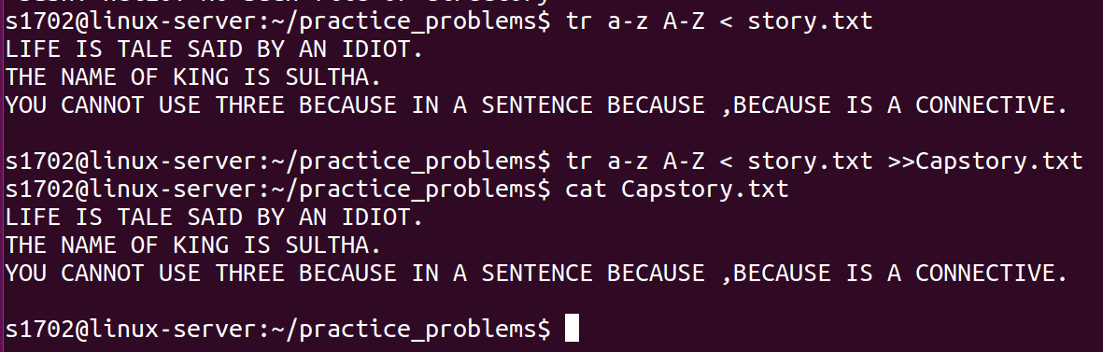
21. Toggle the cases in ‘Story.txt’ and store it in a file ‘Togglestory.txt’.
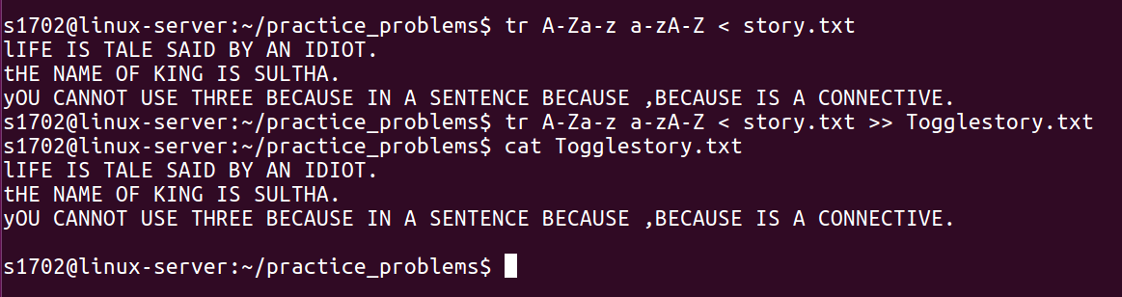
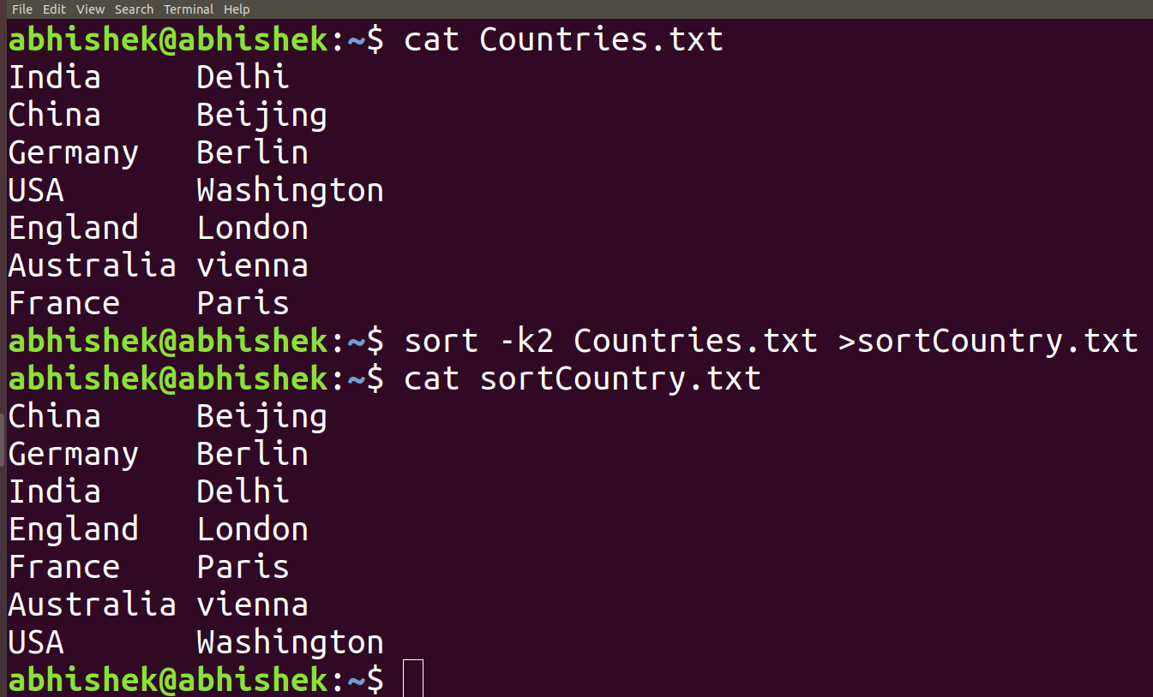
22. Sort the contents of ‘Countries.txt’with Capital as the primary sort key and write the sorted output to ‘SortCountry.txt’

23. Display only the capital cities from ‘Countries.txt’.

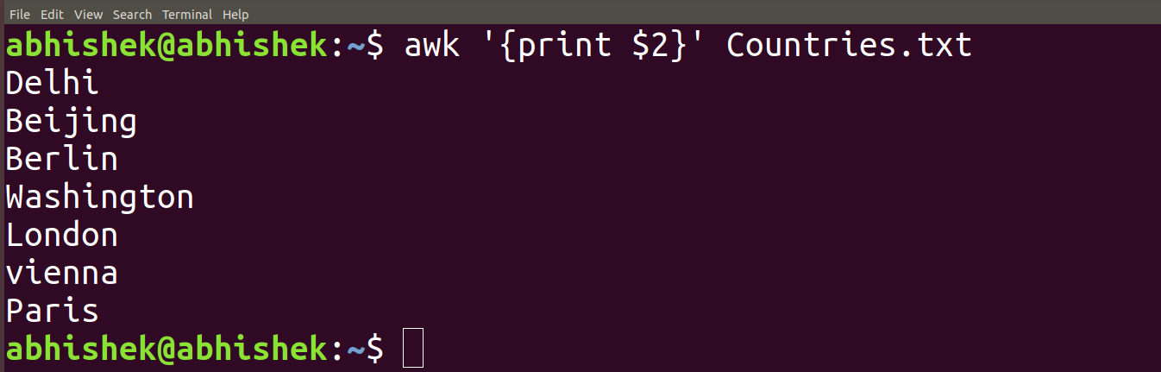

24. Locate all ‘.txt’ and ‘.doc’ files in the current directory .
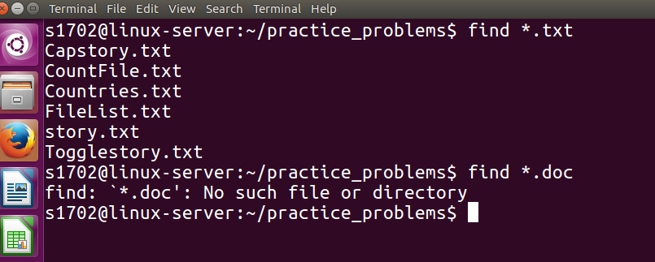
25. Count the number of occurence of ‘the’ in ‘Story.txt’.

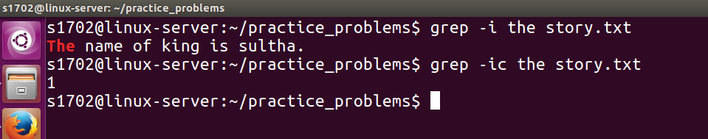

Submitted by
Abhishek Manoharan
Roll number 2

